**Assignment 1: Create an EC2 instance in Linux.**

**Step 1**:

Name: ForAssign1, AMI: Amazon Linux.

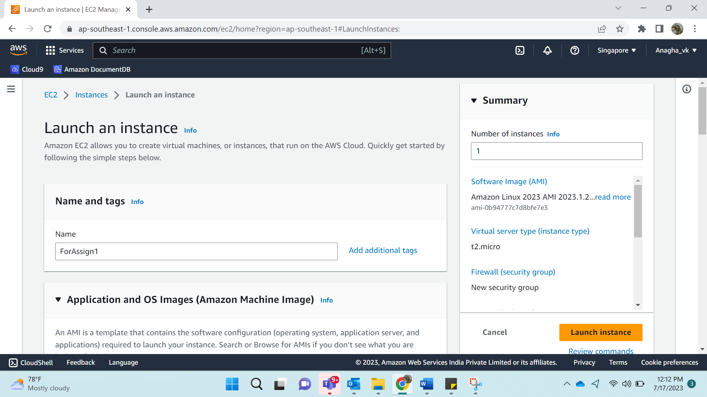

**Step 2:**

Instance type: t2.micro, no of instances: 1

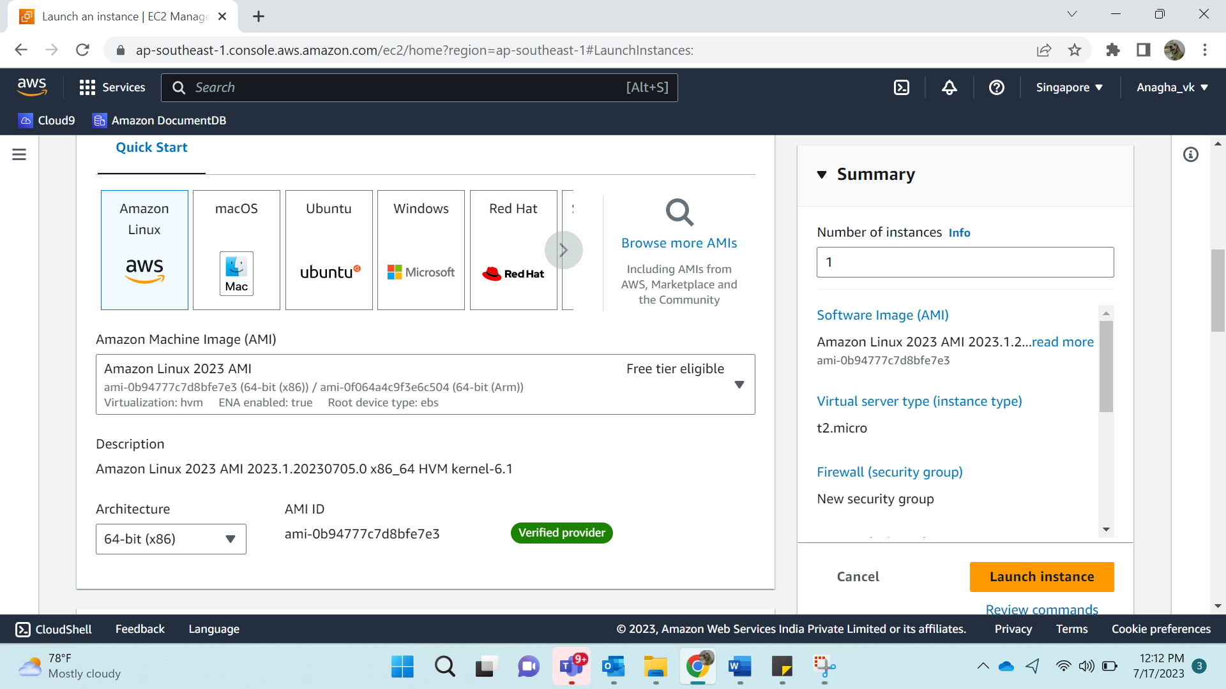

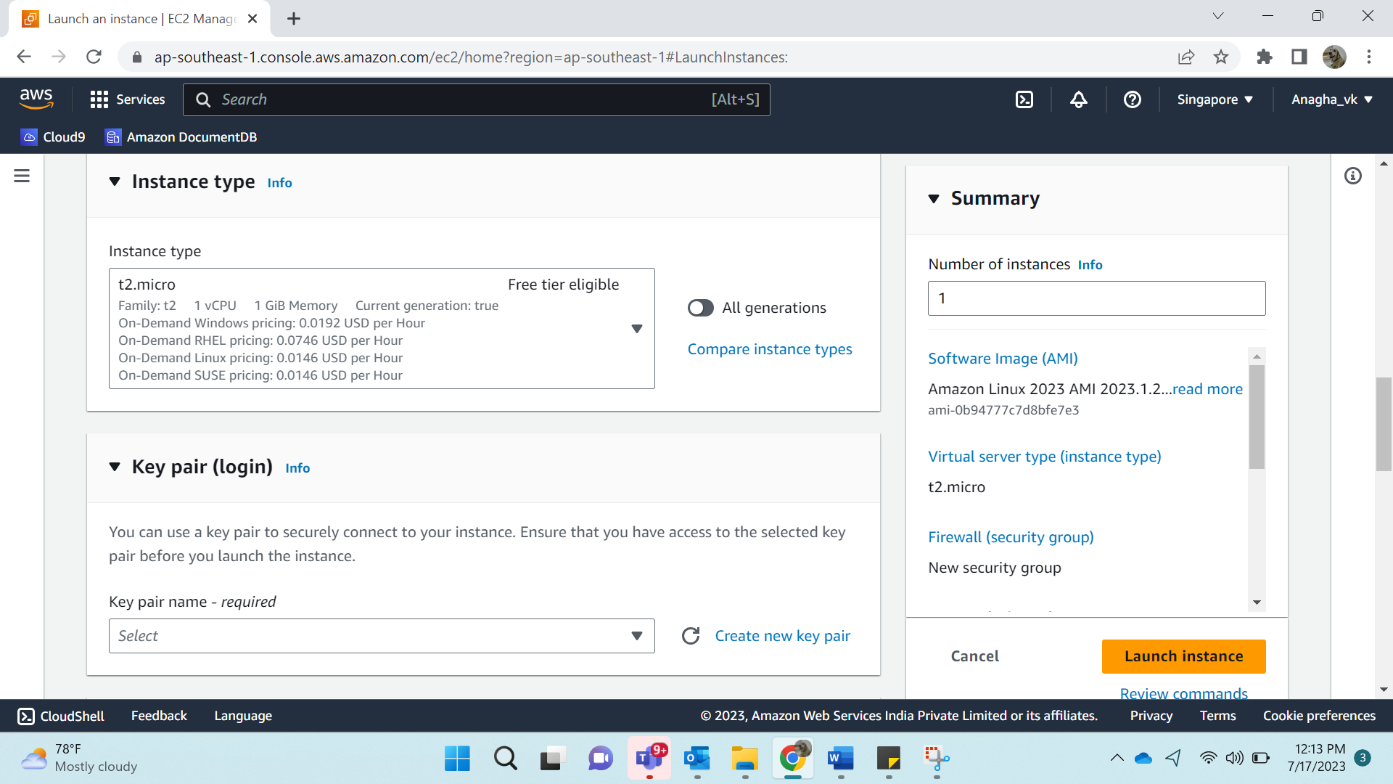

**Step 3:**

I also created Key pair value. Name: keyforassign1 with a .ppk file.

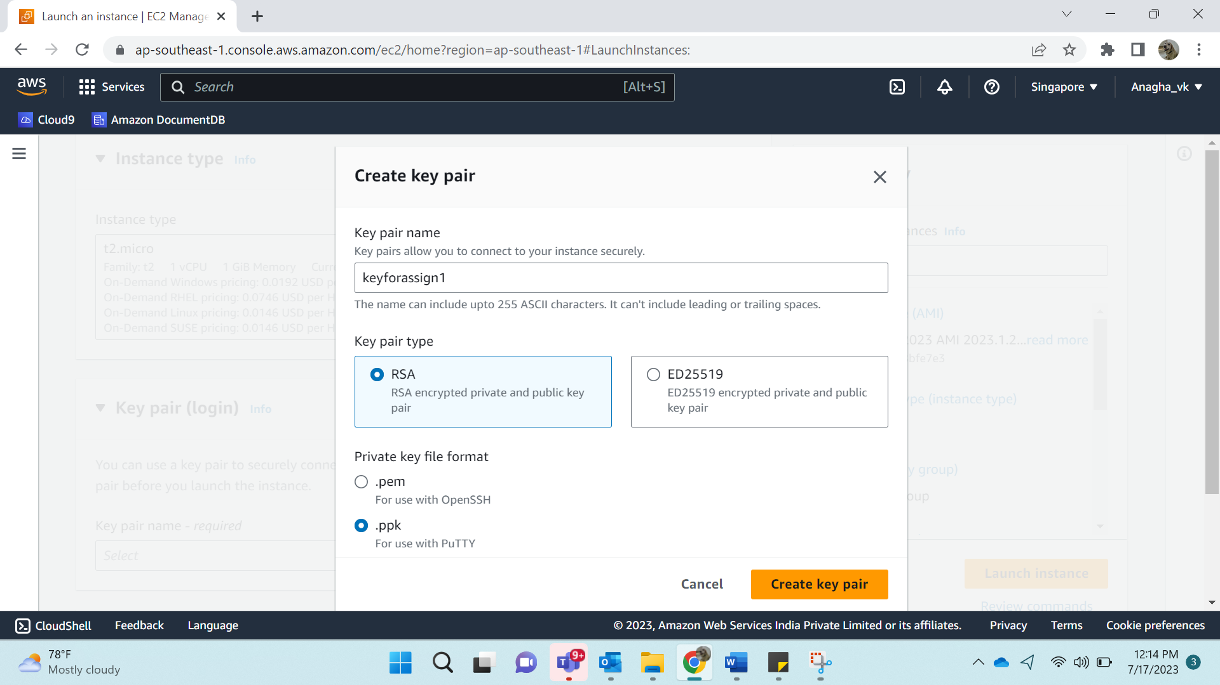

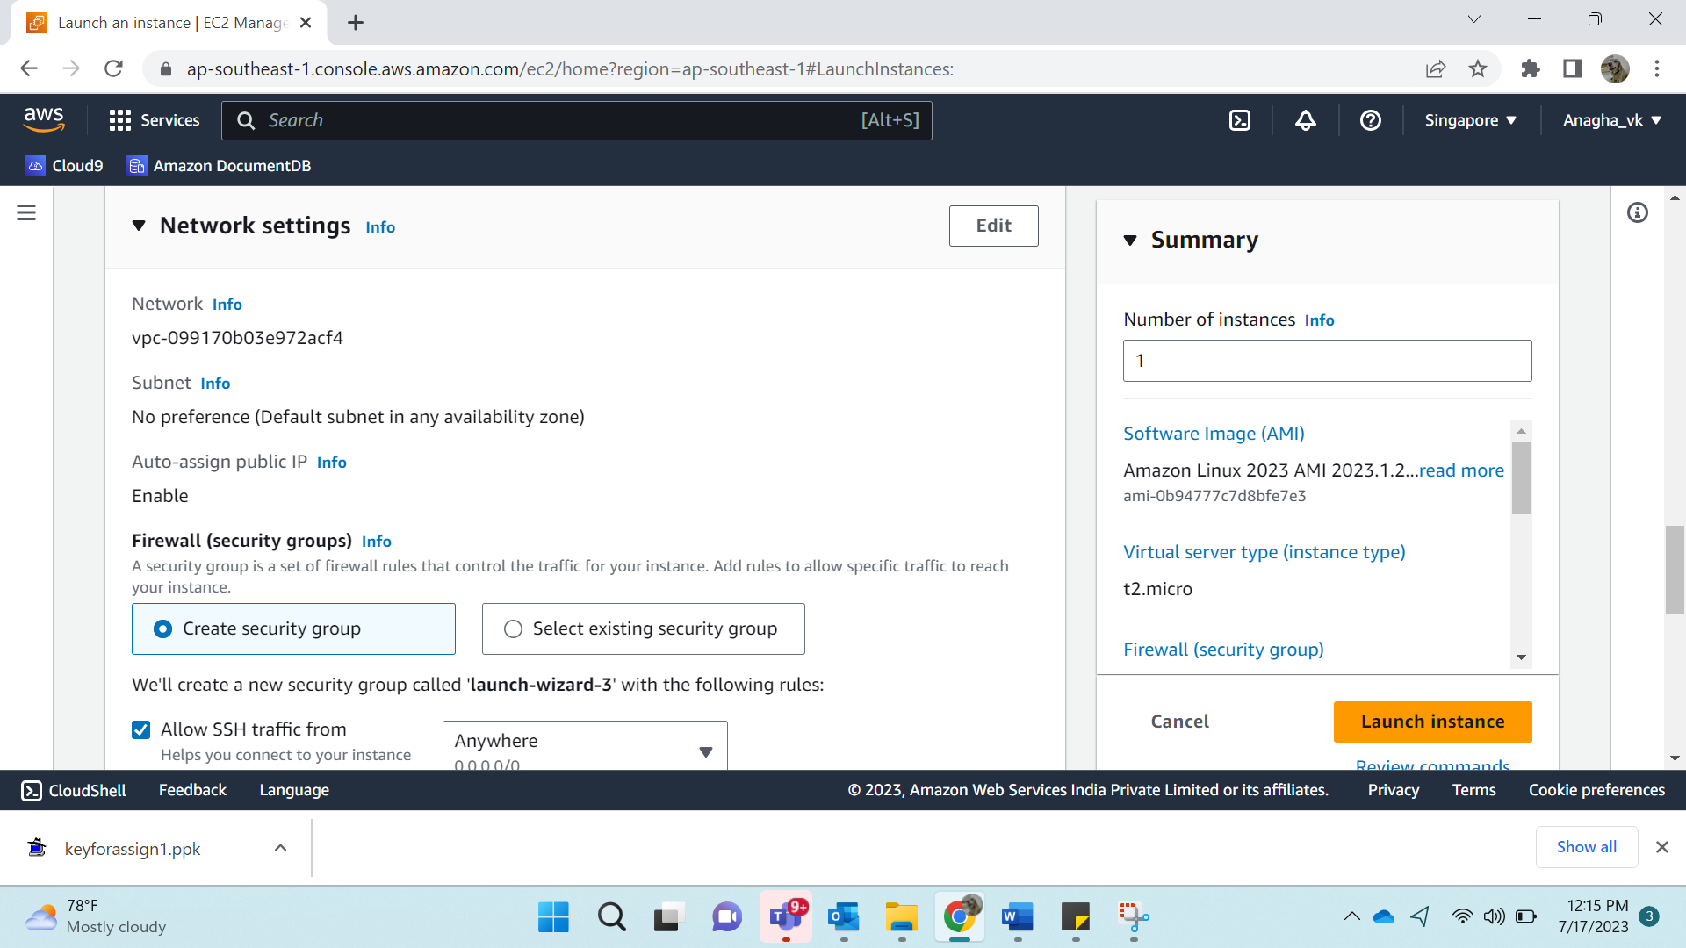

**Step 4:**

I have allowed HTTP and HTTPS traffic with basic storage.

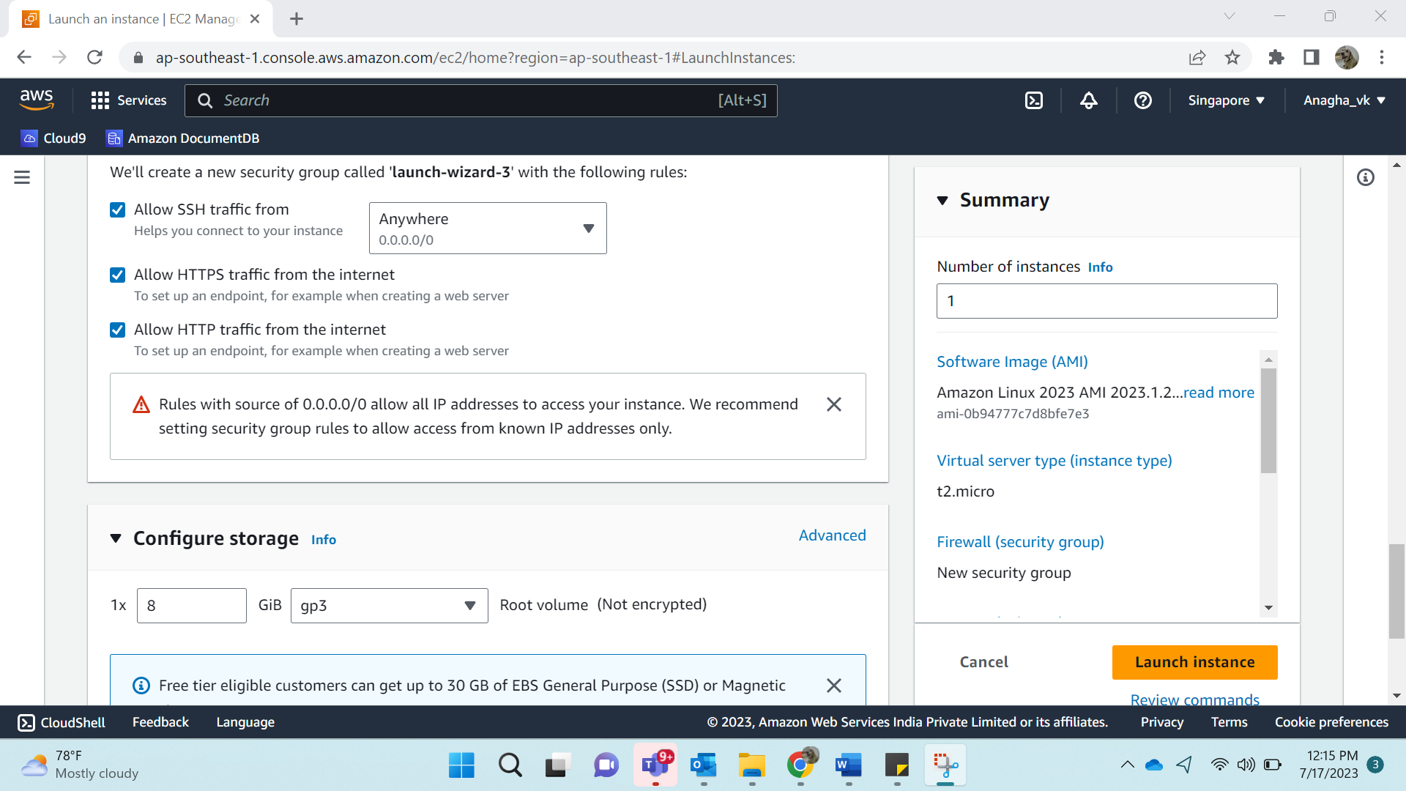

Created Instance:

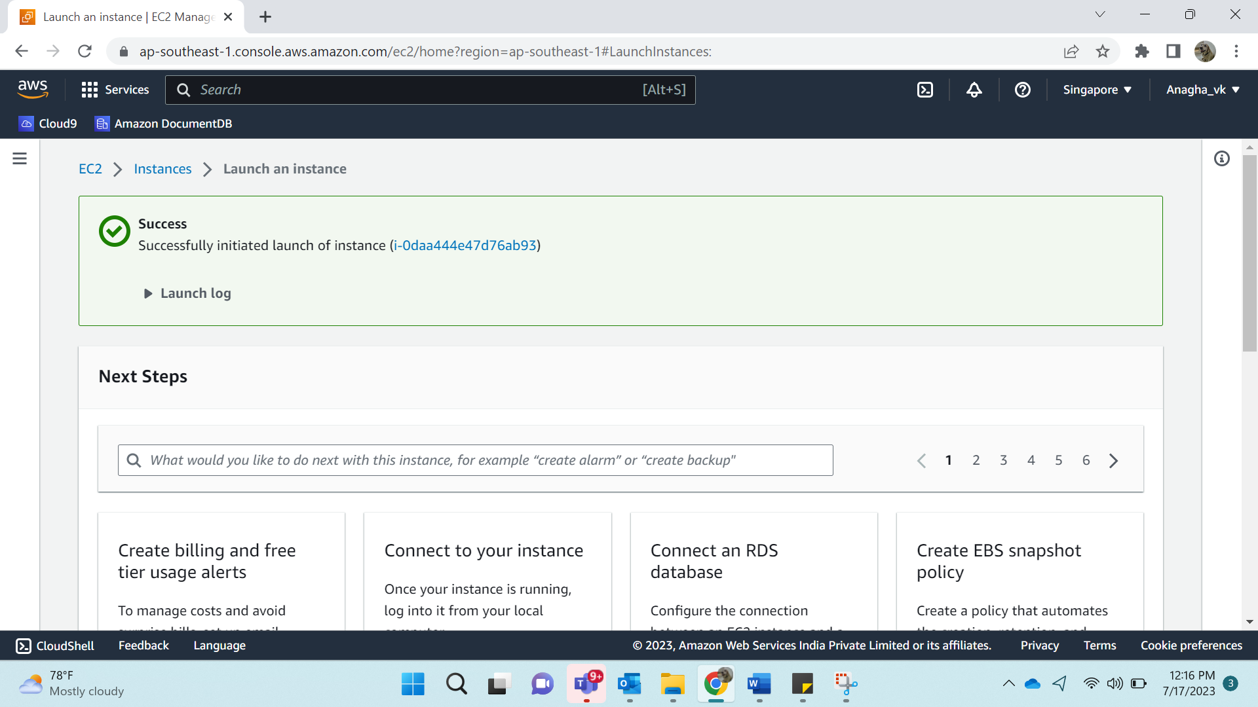

Instance with the IPv4 address.

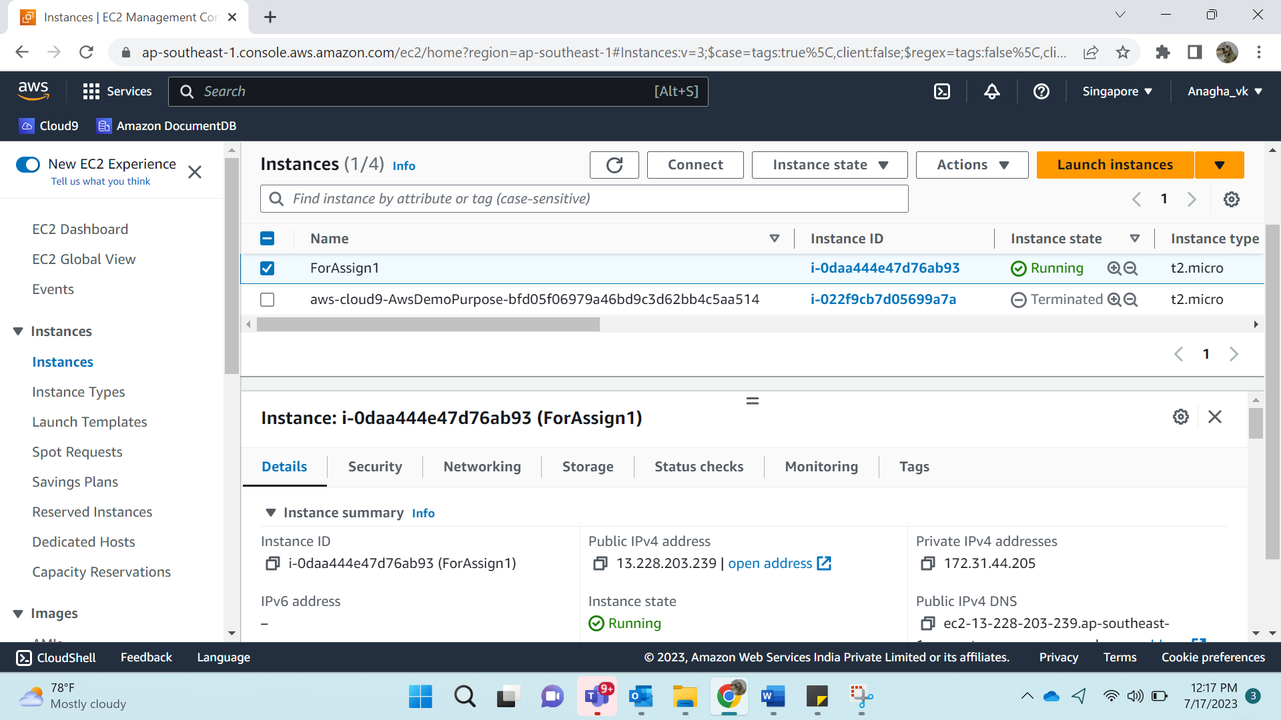

**Step 5:**

Connect via Putty:

Insert the IPv4 address and go to Auth and browse the .ppk file & load.

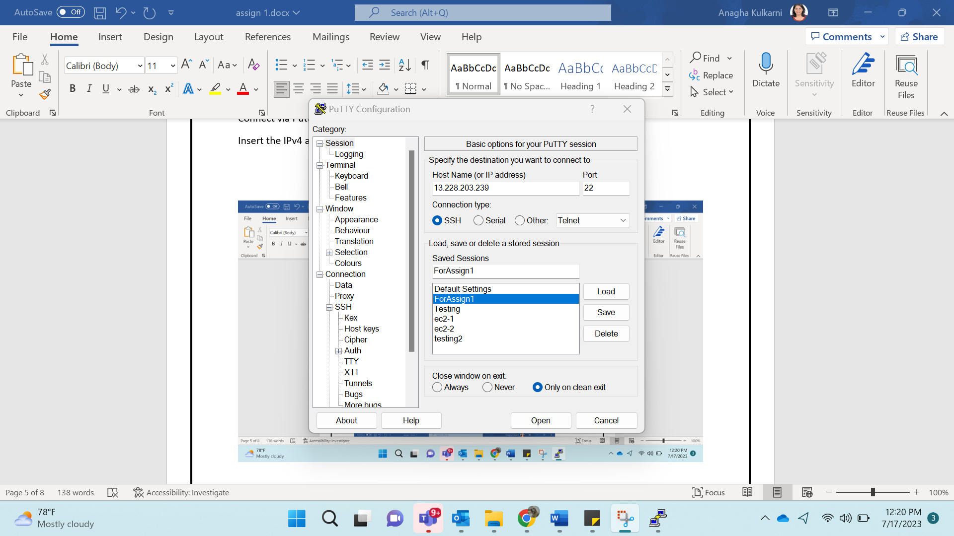

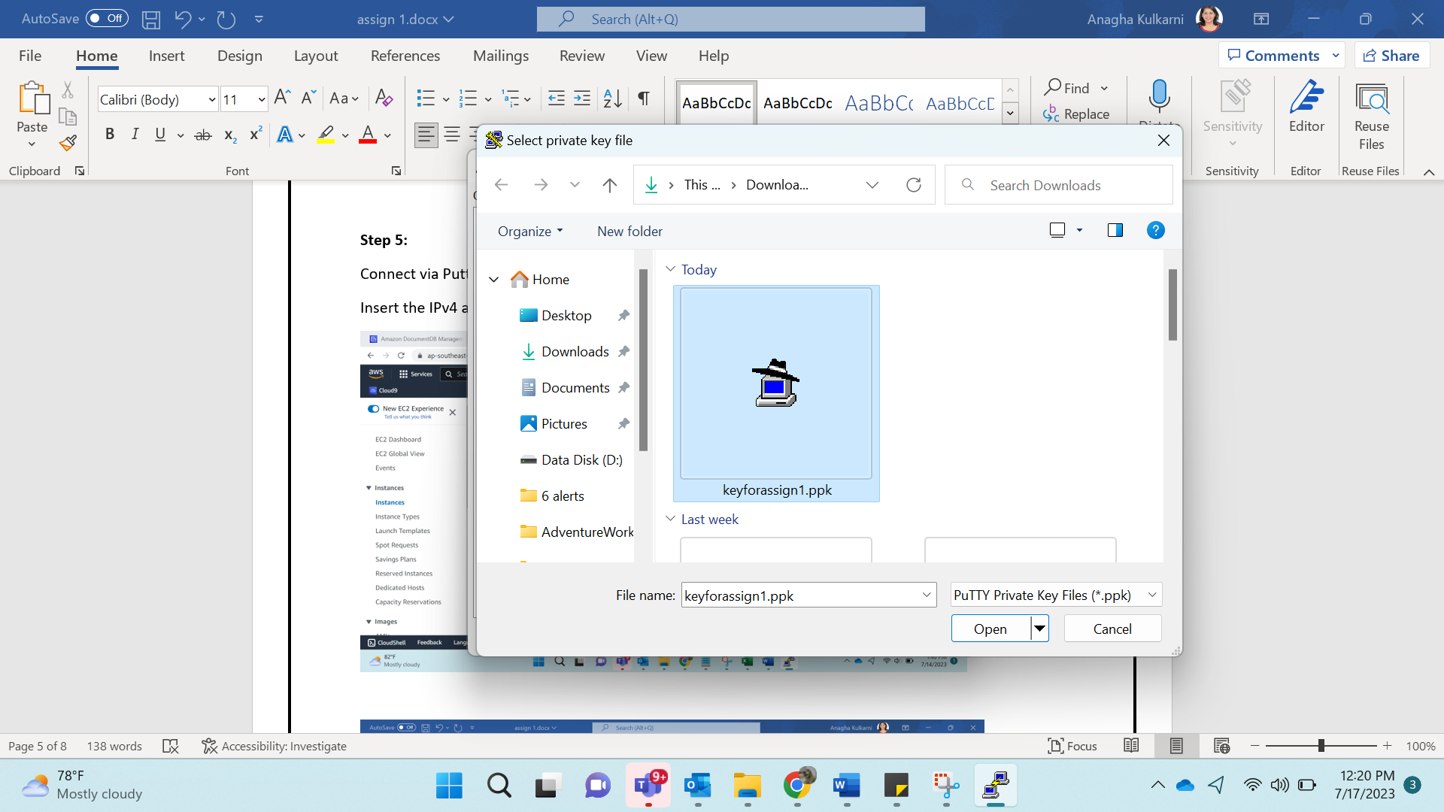

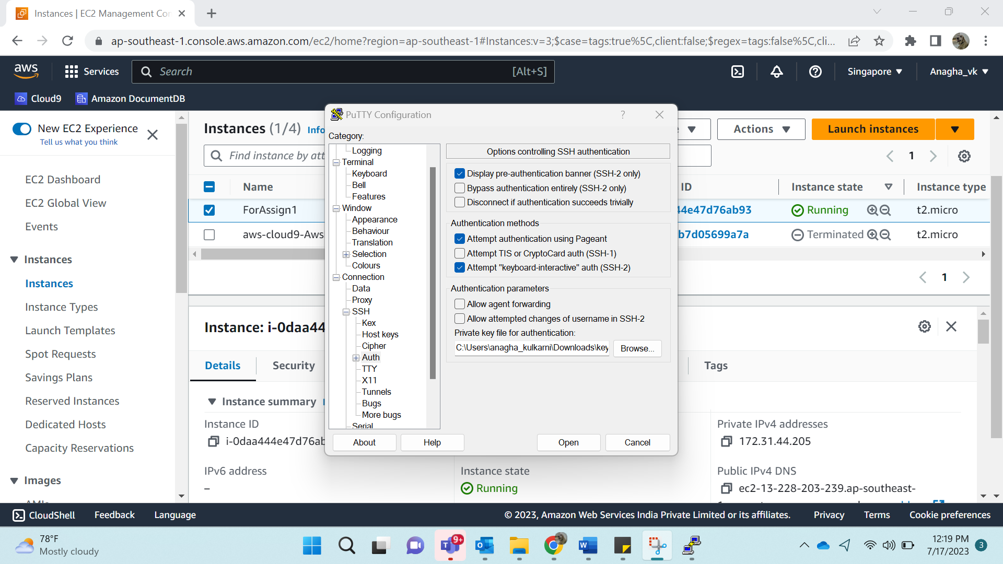

**Step 6:**

Click on Accept

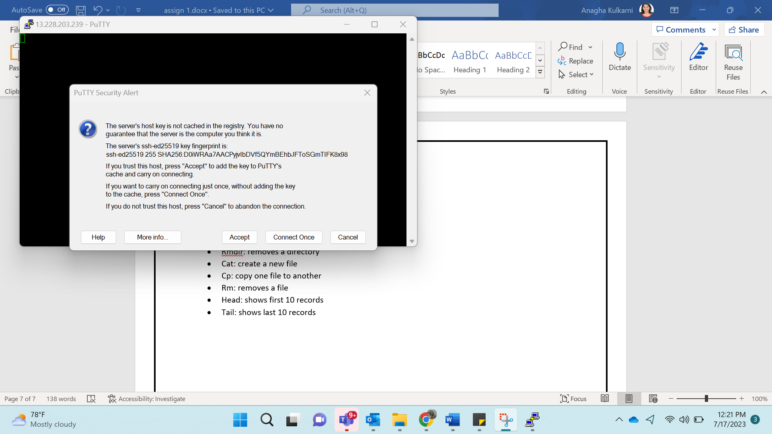

Basic Commands that I know in Linux:

* Sudo su: Login as admin
* Pwd: show the path
* Ls: lists the files in the folder
* Mkdir: makes a directoty
* Rmdir: removes a directory
* Cat: create a new file
* Cp: copy one file to another
* Rm: removes a file
* Head: shows first 10 records
* Tail: shows last 10 records
* Df -h: shows memory storage
* Htop: checks cpu utilization

